|  |  |
| --- | --- |
|  | **[Design & Analysis of Algorithm]**  **[BSCS – 5 A]**  **Department of Computer Science**  **Bahria University, Lahore Campus** |

**Quiz: 1** Date: Week [3], ____ [Feb 2024**]**

Name: _____________________ Roll No: ___________________

|  |  |  |  |
| --- | --- | --- | --- |
| **Evaluation of CLO** | **Question Number** | **Marks** | **Obtained Marks** |
| **CLO1: CLO statement**  **CLO1:** Analyze algorithm (estimate upper and lower bounds without coding and running the algorithm) | 1 | 1.5 |  |
| 2 | 1 |  |
| **Total Marks** | | **2.5** |  |

1. **Which kind of growth best characterizes each of these functions? [1 mark]**

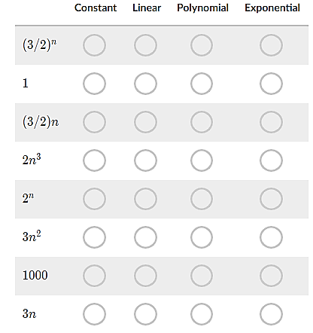

1. **Plot following growth functions asymptotically. [1.5 mark]**

n5.3, 56n+7000